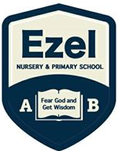 | EZEL NURSERY AND PRIMARY SCHOOL  Home Learning Program  www.ezelschool.com/homelearning.html
Primary Two

Week 1
MONDAY
 | Topics | Activities
Math | - Place value.  - Compare the numbers.  - Draw shapes and learn their properties | Activity: Draw shapes:  1. Draw two circles  2. Draw three squares.  3. Draw four triangles.  4. Draw one rectangle.
English | Language practice | - Vocabulary: Food , water, broom, school  - Sight Words: on , in , we , me
Literacy | Letters and letter sounds  (say the letters and the letter sounds) | Activity:  - Write letters A – Z , a - z  - Write the 5 vowel letters  Examples: apple, box , cat , cow
Story  (Reading) | Feet, hands and head by Brain Wambi  I use my feet to run, jump, and kick.  I use my hands to eat, work, and hug.  But the head is more important than feet or hands.  The head has the eyes. I see with my eyes.  The head has the nose. I smell with my nose.  The head has the ears. I hear with my ears.  The head has the tongue. I taste salty and sweet.  The head has the mouth.  I speak with my mouth.  The head controls the whole body!
TUESDAY
 | Topics | Activities
Math | - Place value.  - Compare the numbers.  - Draw shapes and learn their properties | Activity:  Draw the shapes based on the description and label them:  1. Draw a shape that has four sides. All sides are the same length.  2. Draw a shape that has four sides. Two sides are longer than the other two.  3. Draw a shape that has three sides. All sides can be of the same length or different length.  4. Draw a shape that is round.
English | Language practice. | Vocabulary: Food , water, broom, school  Sight Words: on , in , we , me
Literacy | Say out loud the letters, sounds and words | Letter sound: ch  Syllables of sound ch  Cha , che , chi, cho , chu
Reading | “Feet, hands and head” - Read the story above
WEDNESDAY
 | Topics | Activities
Math | Count numbers, identify numbers and write numbers | - Count from 1 – 100  - Write numbers 50 – 100  - Fill in the missing numbers  1, _____, 3 , ______, 5  22, ____, _____, 25
English | Learn new words | Vocabulary: Food , water, broom, school  Sight Words: on , in , we , me
Literacy | Practicing letter sounds | Letter sound: ch  Syllables of sound ch  Cha , che , chi, cho , chu  Words with letter sound ch:  Chat , Chapati, chips , chalk , chair
Story (reading) | “Feet, hands and head” - Read the story above
THURSDAY
 | Topics | Activities
Math | Count numbers, identify numbers and write numbers | - Count from 1 – 100  - Write numbers 50 – 100  - Fill in the missing numbers  51, _____,5 3 , ______, 55  - 76, ____, _____, 79
English | Identify the of ‘Yes’ or ‘ no’ | Vocabulary: Food , water, broom, school  Sight Words: Yes , No
Literacy | Practicing letter sounds | Letter sound: ch  Syllables of sound ch  Cha , che , chi, cho , chu  Words with letter sound ch:  Chat , Chapati, chips , chalk , chair
Story reading | “Feet, hands and head” - Read the story above
FRIDAY
 | Topics | Activities
Math | Identify figures  Write figures in words | 0 – Zero 1 – one 2 – two 3 – three 4 – four  5 – five 6 – six 7 – seven 8 – eight 9 - nine
English | Using the words ‘Yes’ or ‘ No’ | Example:  - Question: Is that water ?  Answer: Yes , it is.  - Question: Is that a dog?  Answer: No, it is not.
Literacy | Practicing letters, letter sounds | Write the 5 vowel letters.  Write a word for each vowel letter  write letters a - z

Note: Dear parents/caregivers always make sure that
- You explain new words to your child.
- Recite new words as many times as you can
- Be kind and patient with your child, they cannot learn new things in one day.
- Provide your child with books, pencils, crayons and papers.

ACTIVITIES
Activity 1 (Language): Write the story below in your books.
My Holiday
My name is Jovia, I am 6 years old. I spent my holiday with my grandparents.
During the holiday we had a party. It was my grandmother’s birthday party.
On that day, we ate a lot of food like rice, matooke, potatoes and meat.
It was a nice holiday.

Activity 2(language): Write the following words correctly.
Oormb - ______________ oolsch - ________________ neymo - ______________
Oodf - ________________ wtera - ________________ eetr - ________________

Activity 3 (Mathematics): Fill in the missing number
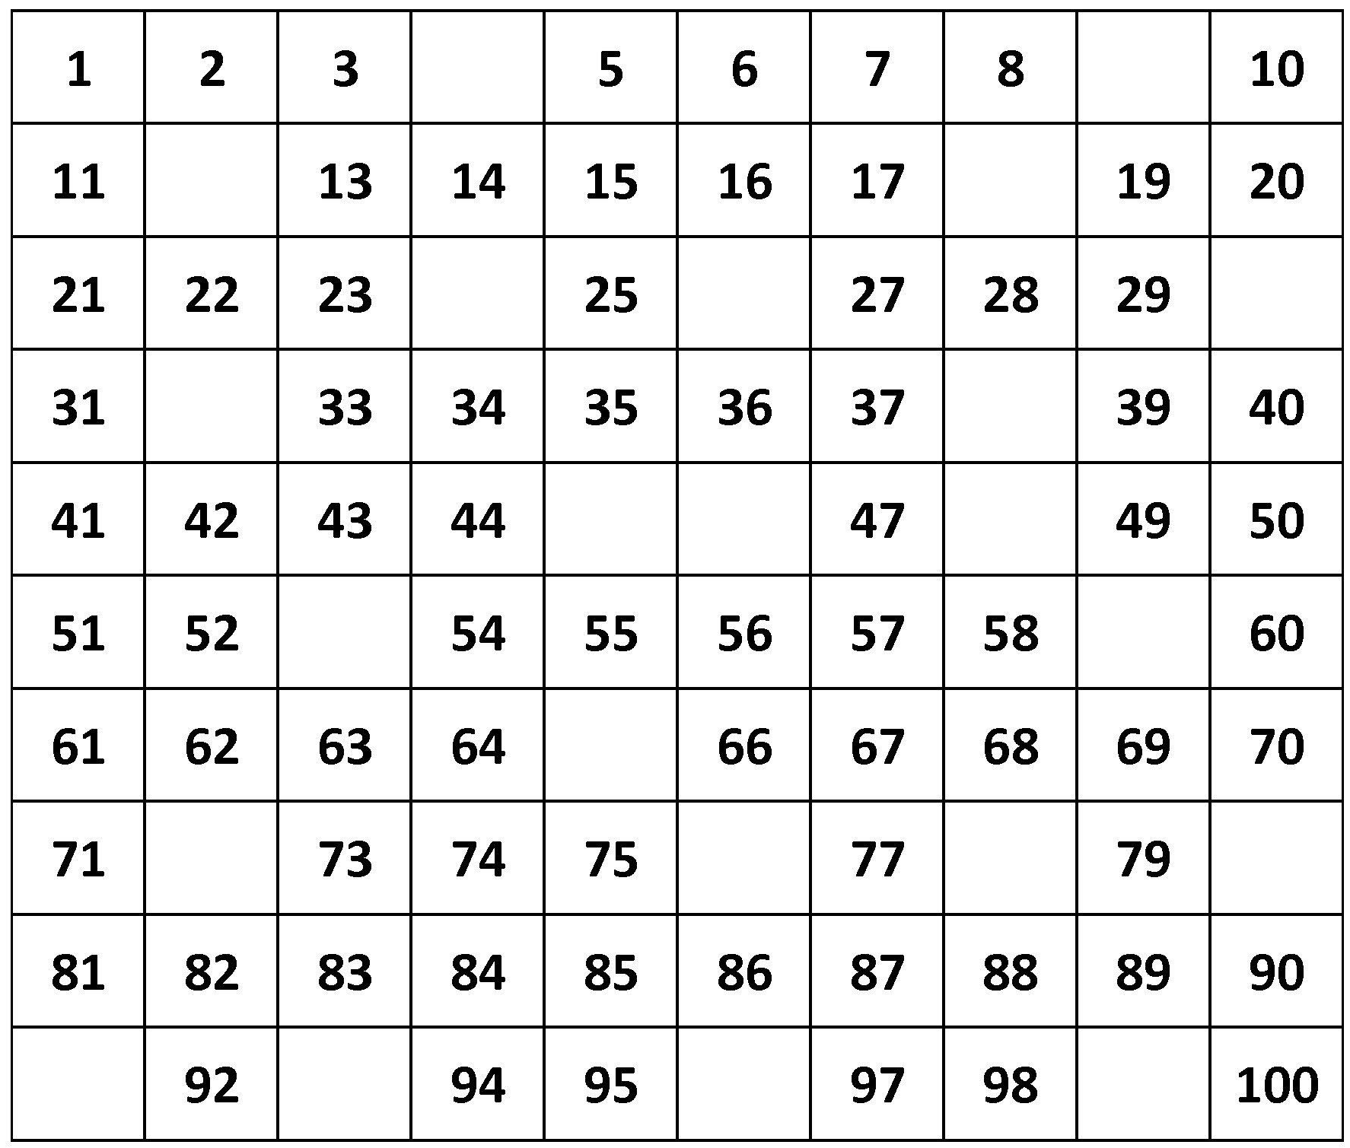
Activity 4 (Mathematics): Write the following numbers in words
1 - ________________ 2 - ______________ 3 - _______________ 4 - ______________
6 - ________________ 10 - ____________ 7 - _______________ 5 - ______________

Activity 5 (literacy) : Write a word beginning with the letter below
- A_______ 2. E______________ 3. I_______________ 4. O____________
Activity 6 (literacy): Write 4 words beginning with the sound ‘Ch’.
- …………………………. 2………………………………… 3……………………………….. 4……………………………..
Activity 7: Circle the things we use at school.
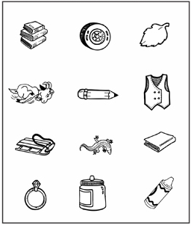
Activity 8: Give answers for the following
- 2 + 6 =  - 4+6 =  - 20 + 3 =  - 9 + 9 =  - 7 +6 = | - 8 + 8 =  - 8 +4 =  - 3 + 8 =  - 5 + 5 =  - 5 + 7 =

For more information, call:
Agule area and all other areas | Kameke Area
0772644523 | 0758650099 | 077074014 | 0786560989 [Director God Help Junior School]

